Game Analysis Worksheet
Name of the game: Monopoly Plus
Publisher: Ubisoft (developed by Asobo Studio); self-published on consoles/PC
Date of Publication: November 24, 2014 (PS4, Xbox One, Xbox 360, PS3); September 7, 2017 (PC/Steam)
Operational Rules
Number of Players and Type of Interaction
1-6 players (single-player vs AI; local multiplayer; online PvP up to 6); competitive PvP with indirect interaction (trades, auctions, rent bankrupting)
Race vs Brawl
Pure Race Pure Brawl
X
1 10
List of actions players can take in the game (Verbs of the game)
Roll dice (standard or Speed Die), move token, buy property, auction bid, trade properties/money/houses, build houses/hotels, pay rent/taxes/fines, mortgage/unmortgage properties, draw Chance/Community Chest cards, collect $200 (pass Go), go to/pay/get out of jail, activate house rules (e.g., Free Parking jackpot)

Goal of the Game
Finite vs Infinite Game (Victory Conditions)
Finite: Bankrupt all opponents (last player with money wins).
Adjustable via house rules/Speed Die for shorter games;
optional point/time limits.

Feedback Systems
Physical elements | Visual elements
Tactile  X  1 5 | Aesthetic Appeal  X  1 5
Kinesthetic  X  1 5 | Legibility  X  1 5
Audio Elements | Conceit Matrix
Music/ sfx  X  1 5 | 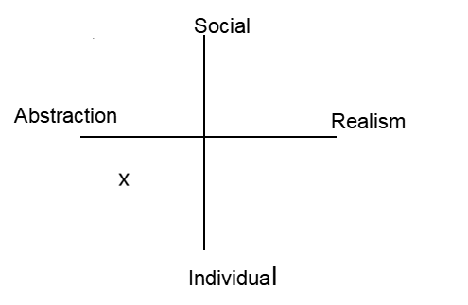
Player sound

X
1 5

Magic Bullet Analysis
Must Learn
Psychomotor | Cognitive | Affective
Controller/mouse navigation, dice roll input, menu selections (buy/trade) | Property costs/rent calculations, color set completion, basic trading | Excitement of first property buy, frustration of rent payments
Can Learn
Psychomotor | Cognitive | Affective
Quick auction bidding, rapid trade proposals | House/hotel optimization, Speed Die strategies, house rule synergies | Negotiation thrill, tilt control in long games
External Learning
Psychomotor | Cognitive | Affective
Basic controller proficiency | Arithmetic (addition/subtraction for cash flow) | Competitive multiplayer tolerance
Coincidental Learning
Psychomotor | Cognitive | Affective
Muscle memory for menus/trades | Financial planning (cash reserves, ROI on houses), risk assessment (mortgaging) | Resilience to bankruptcy, social bonding via voice chat
Bullet Sketch

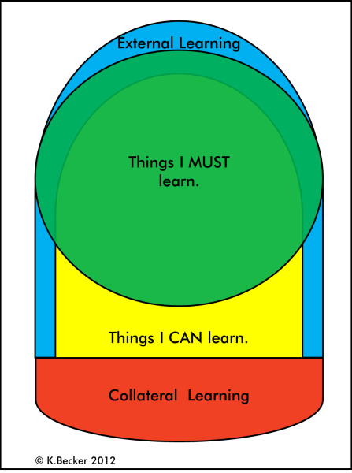

Other Notes:
Monopoly Plus is a digital version of the classic Monopoly with 3D graphics, Speed Die, online multiplayer, and voice chat. The main idea is to develop financial literacy through a live simulation of money management, investments, and risks. The player allocates starting capital, plans a budget, creates a reserve for taxes and rent, invests in property for passive income, and risks bankruptcy. Automated calculations allow for greater focus on strategy. Lew and Saville (2021) studied a modified Monopoly with disruptive events on 77 participants over 10 years. The methodology used was content analysis and behavioral trend analysis. Conclusion: the game teaches about the investment environment, financial management, alliances, and human factors. Quote: "This paper investigates the application of a modified version of the board game of Monopoly... The results show the breadth of learning through the game of Monopoly that was modified by incorporating disruptive elements" (abstract). In Monopoly Plus, online trading and Speed Die reinforce these lessons. Mathematics is practiced through rent and probability calculations (the sum of 7 on the dice is 1/6). Kuang et al. (2021) demonstrated in an experiment with 144 schoolchildren that Modified Monopoly outperforms CAI in higher-order thinking and retention. Quote: "These results offer evidence for the significant and more enduring learning benefits that Modified Monopoly can produce in students' higher-order thinking skills" (abstract). Social skills are developed in voice chat: persuasion, bluffing, compromise. According to Bloom's taxonomy (Anderson & Krathwohl, 2001), the coverage is complete: memorization → application → risk analysis → strategy creation. Monopoly Plus — 4.4–4.6/5: Speed, automation, and social boost make it a great financial literacy tool for the digital age.

